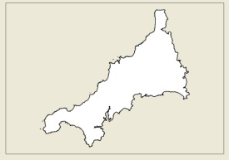
Please return this Notice of Appeal form to the preferred school for the attention of the School Secretary

CORNWALL SCHOOL
ADMISSION APPEALS PANEL

Name and relationship to the child of person making Appeal: | Address:
Name of Child: | Day time Tel No:
Date of Birth: | Mobile Tel No:
Preferred School: | Do you wish to attend Hearing?

Grounds for Appeal (Please continue on separate sheet, if necessary)

Signed ………………………………………………………………………………….. Date ………………………………

The information you provide on this form is collected by Cornwall Council as data controller in accordance with the data protection principles contained within the Data Protection Act 1998. The purpose for collecting the data is to process your appeal to the School Admission Appeals Panel. Any personal data collected will not be shared with any third parties without your permission. If you have any concerns regarding the processing of your data then please contact the Clerk to the School Admission Appeals Panel.

